Custom PBI Column Chart

Aka stackedHistogramLined

User Manual

February 17, 2022

Custom PBI Column Chart

Aka stackedHistogramLined

# Table of Contents

Table of Contents 2

Getting Started 4

Background 4

Setup 5

Adding Data 6

Sample Charts 7

Features & Settings 8

Default Settings 9

Layout 10

Chart Type 10

Chart Horizontal/Vertical Margin 11

Horizontal Bar Spacing 11

Y Scale Factor 12

Capacity 13

Label X/Y Offset 13

X-Axis 15

Y-Axis 16

Max Value 16

Axis Tick Count 17

Secondary Y-Axis 18

Min/Max Value 18

Data Colors 20

Data Labels 21

Sum Label Display Tolerance 22

Bar Label Display Tolerance 24

Legend Settings 25

Legend Position 25

Threshold 27

Align to Secondary Y-Axis 27

Primary Growth Selectors 29

First/Second Selection (Stacked Column Chart) 29

First/Second Selection (Clustered Column Chart) 30

Primary Growth Labels 32

Min Label Width 33

Label Offset Height 34

Primary Line Settings 35

Align Primary Indicators 36

Line Offset Height 36

Secondary Growth Selectors 37

First Selection(s) 37

Second Selection(s) 37

Bar Group Selector(s) 38

Secondary Growth Labels 39

Horizontal Offset 40

Secondary Line Settings 41

Changelog 42

Custom PBI Column Chart

Aka stackedHistogramLined

# Getting Started

This guide is designed to provide you with a detailed understanding of how to use this chart. You can navigate directly to section headers by clicking on the corresponding name in the **Table of Contents**. Links will also be found throughout this guide like this.

You may find the following resources helpful:

**Microsoft Power BI Documentation:** <https://docs.microsoft.com/en-us/power-bi/>

**Github Repository:** <https://github.com/jesse-xia/stackedHistogramLined>

## Background

Since shifting our monthly report over to Power BI, default Power BI charts have been limiting – many features offered in Excel and PowerPoint were not available in Power BI. The Custom PBI Column Chart aims to solve this issue by extending the capabilities of default Power BI visuals and delivering something that is interactive, easy to use, visually informative, and aesthetically pleasing. This chart is designed to display historical KPI data to be presented in a monthly report. It builds upon the functionality of a regular Power BI chart by adding additional visual indicators and customizable options.

## Setup

To import a custom visual, click on the three dots in the **Visualizations** panel.

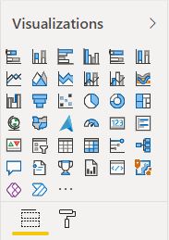

From the dropdown, select **Import a visual from a file**.

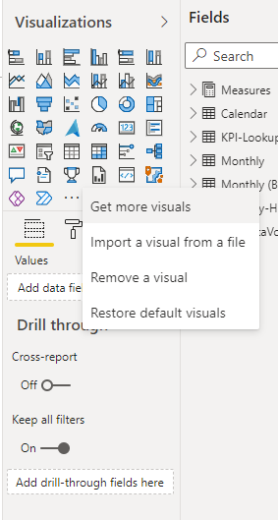

Find and select **stackedHistogramLined** from your filesystem and click **Open**.

You should now see a new icon in your visualizations panel.

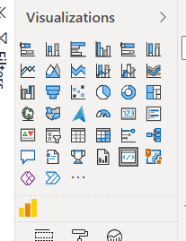

Clicking on this icon will insert the visual into your report.

## Adding Data

After inserting the visual, it will not display anything until it is populated with data.

Underneath the **Visualizations** panel, you’ll find several empty fields.

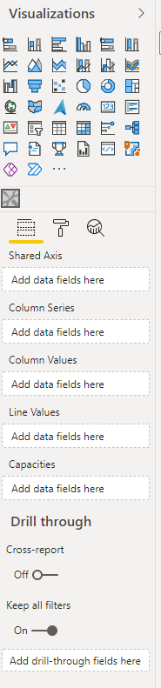

**Shared Axis –** X-axis values that will be displayed on the chart.

**Column Series –** Categories that will display along the y-axis of the chart.

**Column Values –** Data values that will display along the y-axis of the chart.

**Line Values –** Values that determine the “threshold”, a line that will span the width of the chart.

**Capacities –** Capacities are displayed alongside the regular column values as its own separate column.

### Sample Charts

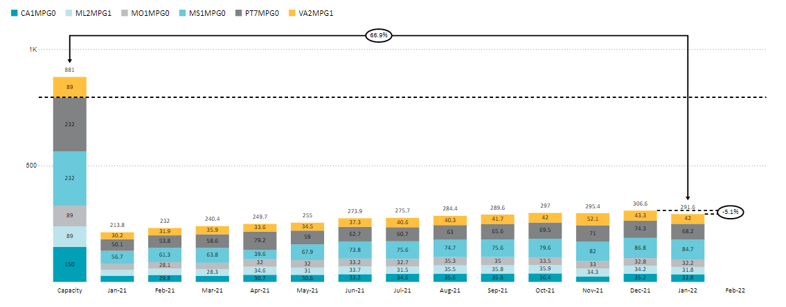

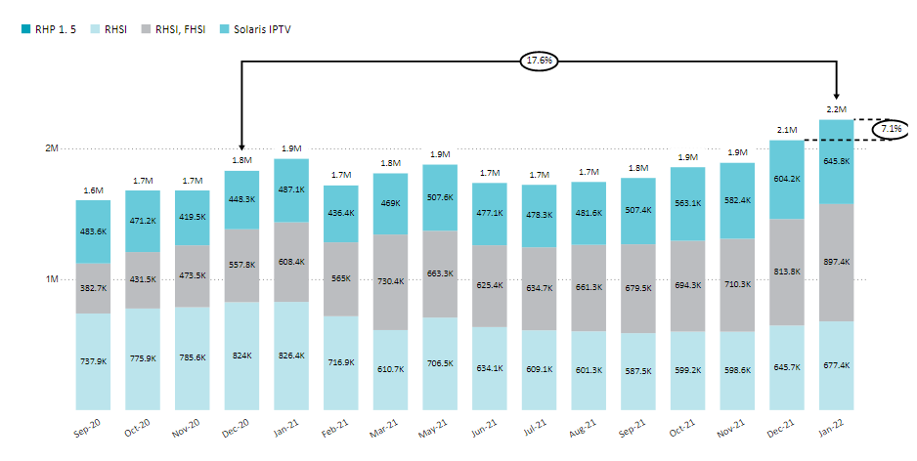

Custom PBI Column Chart

Aka stackedHistogramLined

# Features & Settings

This section will cover all configurable options offered by this visual. After clicking on the visual, these options can be found in the **Visualizations** pane under **Format**.

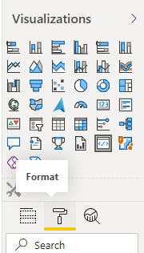

## Default Settings

The default settings offered by Power BI include **General, Title, Background, Border, Shadow, Lock Aspect,** and **Visual Header.** These settings will not be covered in this manual as they are not unique to this visual. Additionally, settings that are self-explanatory or commonly found in other tools will not be covered, as these are obvious and easy to understand.



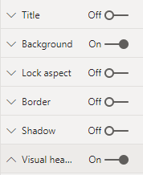

## Layout

Defines the general structure of the chart.

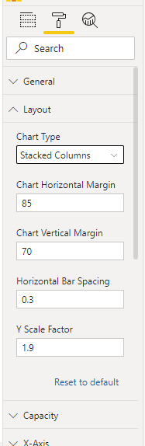

### Chart Type

Switches between **Clustered** and **Stacked** column charts.

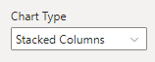

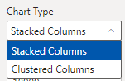

### Chart Horizontal/Vertical Margin

The margins define the whitespace around the inside border of the visual.

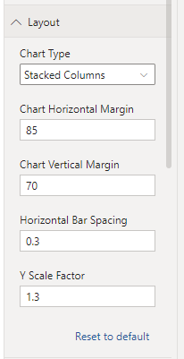

### Horizontal Bar Spacing

Sets the amount of whitespace between the bars, expressed as a percentage of the bar width. For example, a value of 0.3 indicates that the spacing between bars should be equal to 30% of the width of one bar.



### Y Scale Factor

Allows you to adjust the default scaling of the max y-value. The max y-value will be set to largest column multiplied by the y scale factor.



## Capacity

Adjusts settings specifically for the capacity column.

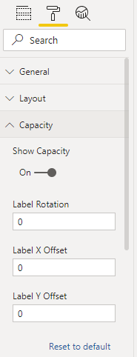

### Label X/Y Offset

Label x/y offset allows you adjust the x/y position of the axis labels relative to their original position.



## X-Axis

Adjusts the horizontal axis of the chart.

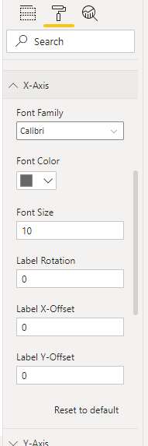

## Y-Axis

Adjusts the vertical axis on the left side of the chart.

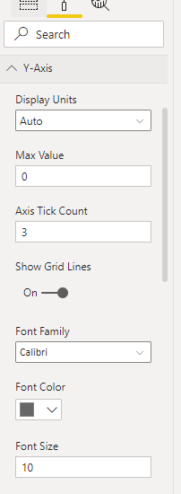

### Max Value

Defines the maximum value of the scale along the y-axis. It’ll be automatically adjusted based on the magnitude of the data, though it’ll appear as 0 in the input box until another value is entered.



### Axis Tick Count

Sets the number of labelled values along the y-axis scale. The number of ticks is determined by dividing the range (from 0 to the **Max Value**) by the desired tick count. If the tick count does not divide evenly, the value will automatically be rounded to the nearest whole number.

## Secondary Y-Axis

Configures the secondary y-axis on the right side of the chart, which can be used to position the threshold.

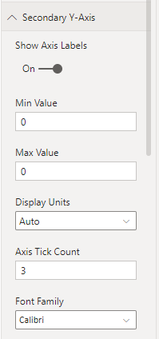

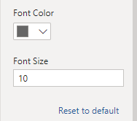

### Min/Max Value

Defines the minimum/maximum value of the scale along the axis.



## Data Colors

**Data Colors** is a setting offered by default Power BI charts, though some additional functionality has been added here. Under the **Data Colors** section, you’ll find a list of all the data categories provided by the current dataset, alongside color selections for **Bar Label** and **Serie Color**.

The **Bar Label** **Color** determines the color of the labels on the bars for a specific category. This is not to be confused with the **Bar Label Font Color** under the **Data Labels** section, which will uniformly adjust the label color for *all* categories. In most cases, the color specified under **Data Colors** will override the label color under **Data Label Settings**. (See developer notes for more details)

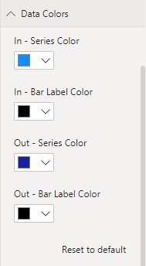

Example of a particular **Data Colors** section. This will differ depending on your dataset.

## Data Labels

Allows you adjust the labels for the bars displayed on the chart. Labels positioned above the bars are referred to as “sum labels” while labels positioned on the bars are “bar labels”.

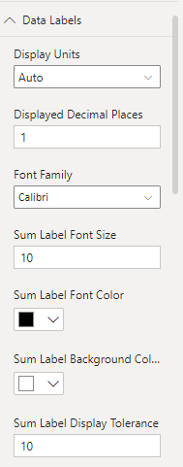

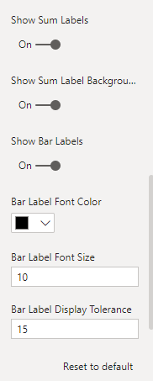

### Sum Label Display Tolerance

Adjusts the available width for which sum labels will display. Sum labels will display only if the bar width + the display tolerance is greater than the width of the label text.



### Bar Label Display Tolerance

Adjusts the available width for which sum labels will display. Sum labels will display only if the bar width + the display tolerance is greater than the width of the label text.



## Legend Settings

Adjusts the legend.

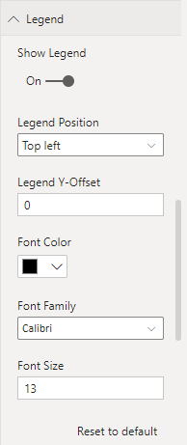

### Legend Position

Sets legend position.

**Top Left**: Displays in top left corner, horizontally.

**Bottom Center**: Displays centered at the bottom, horizontally.

**Left**: Displays along the left side, vertically.



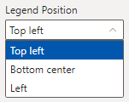

## Threshold

The threshold displays as a horizontal line spanning the width of the chart.

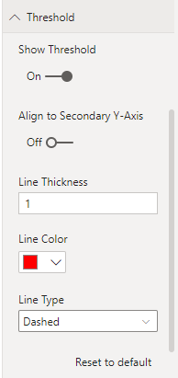

### Align to Secondary Y-Axis

Sets the threshold to scale based off the secondary y-axis instead. By default, the threshold will scale based on the primary y-axis (on the left side). Toggling this option will allow you to manually adjust the displayed height of the threshold using the min/max values for the secondary y-axis.



## Primary Growth Selectors

Indicator values express the change from the first selection to the second selection as a percentage. The only exception occurs when the first selection is the capacity column, where the value displays the precent change from the second selection compared to the first.

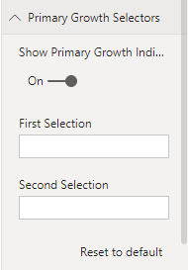

### First/Second Selection (Stacked Column Chart)

The selectors allow you to select the column series or category that you would like to compare. Selections are always case- and punctuation- sensitive.

The selectors will accept the name of any column along the x-axis (typically in the form of month-year, ex. Nov-22). If the first selection is blank and capacity is a non-zero valid column, the first selection will default to the capacity column. If the second selection is blank, it will default to the most recent non-zero available month.

If capacity does not exist, the selections will default to the 13-month range. If that is not available, it will attempt to select the next largest range (12-month), and decrement until a valid selection is found.

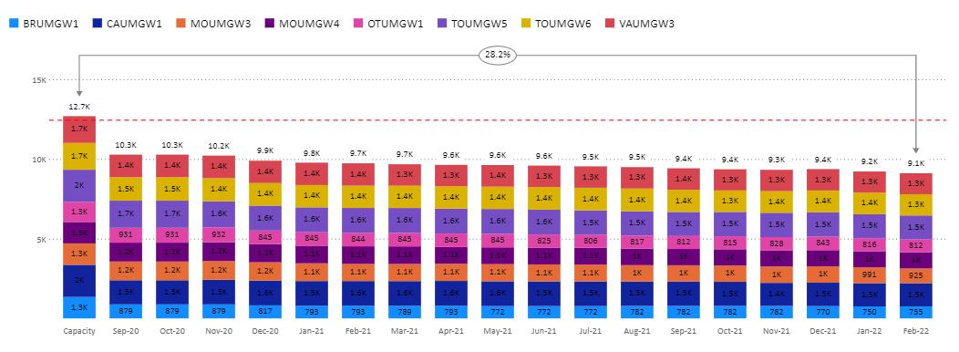

Selects capacity column/most recent non-zero month by default

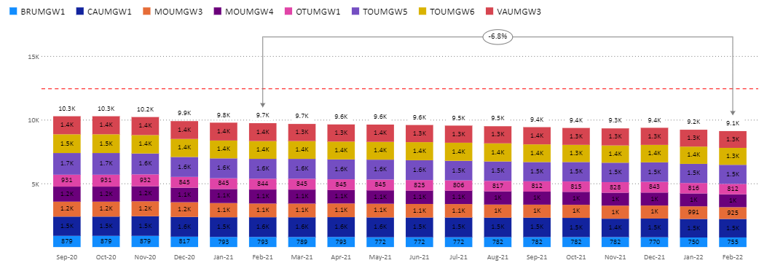

Selects 13-month range when capacity is not available

### First/Second Selection (Clustered Column Chart)

The selectors will the accept the name of any category of values. By default, it will select the last two categories, with the second selection selecting the last category and the first selection selecting the second last category.

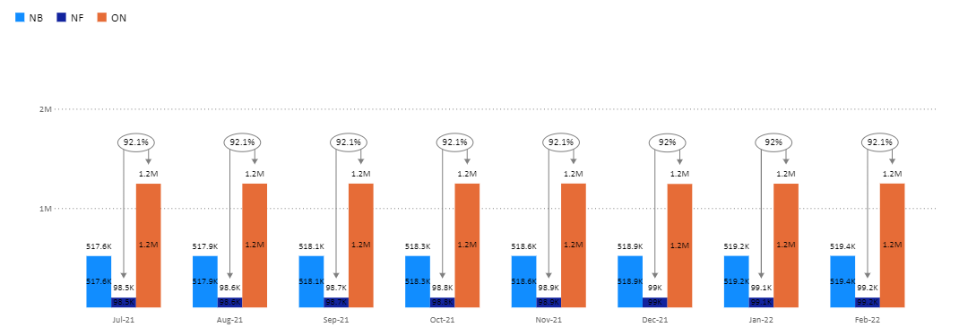

Selects last two categories by default

## Primary Growth Labels

Adjusts settings for primary growth labels.

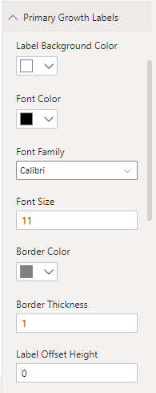

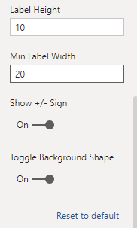

### Min Label Width

Sets the minimum label width. Labels will automatically resize to fit the content, though it will never go below the minimum label width.



### Label Offset Height

Adjusts the vertical position of the label relative to its original position.



## Primary Line Settings

Adjusts line settings for primary growth indicators.

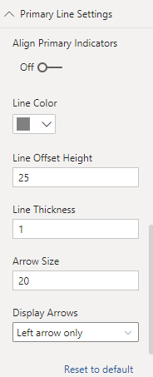

### Align Primary Indicators

Displays all primary indicators aligned at the top of the chart. This only applies to the clustered column chart.



### Line Offset Height

Sets the whitespace between the top of the bars and the start of the line.

## Secondary Growth Selectors

Indicator values express the change from the first selection to the second selection as a percentage.

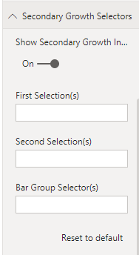

### First Selection(s)

The first selection allows you to select the first column series or category that you would like to compare. Selections are always case- and punctuation- sensitive. To select multiple items, separate the names with a comma.

In a stacked column chart, the first selection will accept the name of any column along the x-axis (typically in the form of month-year, ex. Nov-22). If no selection is provided, it will default to the second-from-last selectable column.

In a clustered column chart, the first selection will the accept the name of any category of values. By default, it will select the second-from-last category.

### Second Selection(s)

The second selection operates exactly like the first selection.

In both stacked and clustered forms, if no selection is provided, it will default to the last selectable column.

### Bar Group Selector(s)

The “bar group” refers to a specific label along the x-axis (ex. period) where the secondary growth indicator will display. By default, the bar group selector will select the rightmost label (ex. most recent period). Entering any other value will automatically override the default selection. Multiple values are also acceptable. For example, if you wanted to display secondary growth indicators for both Jan-22 and Feb-22, you would enter both “Jan-22” and “Feb-22” separated by a comma. Selections are always case- and punctuation--sensitive

## Secondary Growth Labels

Adjusts the label properties for the secondary growth indicators.

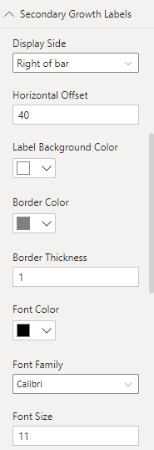

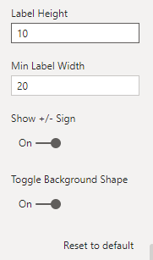

### Horizontal Offset

Adjusts the horizontal position of the label relative to its original position.



## Secondary Line Settings

Adjusts the line properties for the secondary growth indicators.

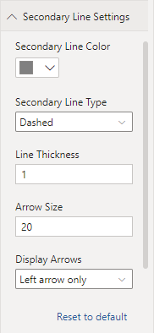

# Changelog